**SEQUENCE DIAGRAM**

**(AIR TICKET RESERVATION SYSTEM)**

1. **LOGIN AND SIGNUP SEQUENCE DIAGRAM**

**BASIC FLOW :**

* 1. Actor Logs into the system

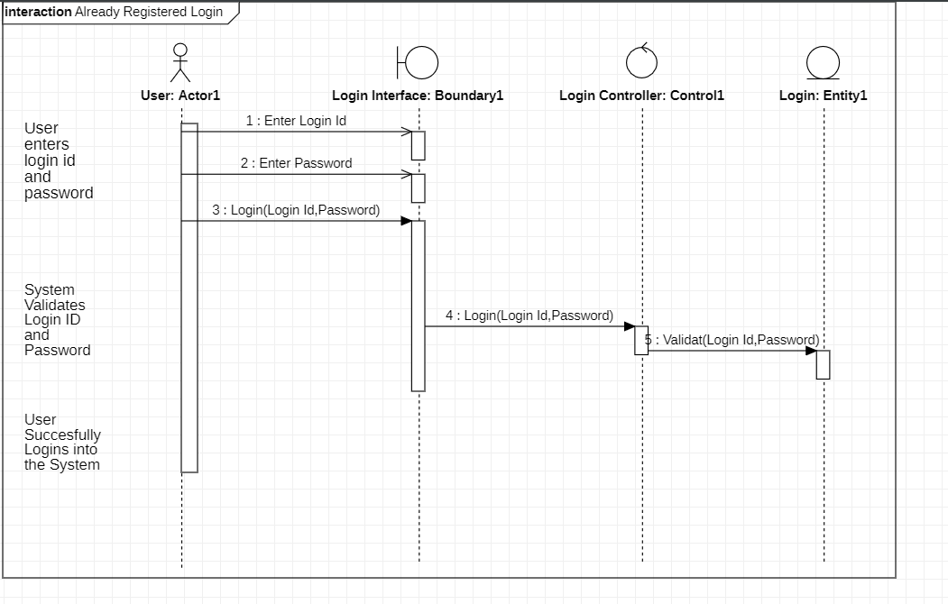

* 1. Actor tries to sign up into the system

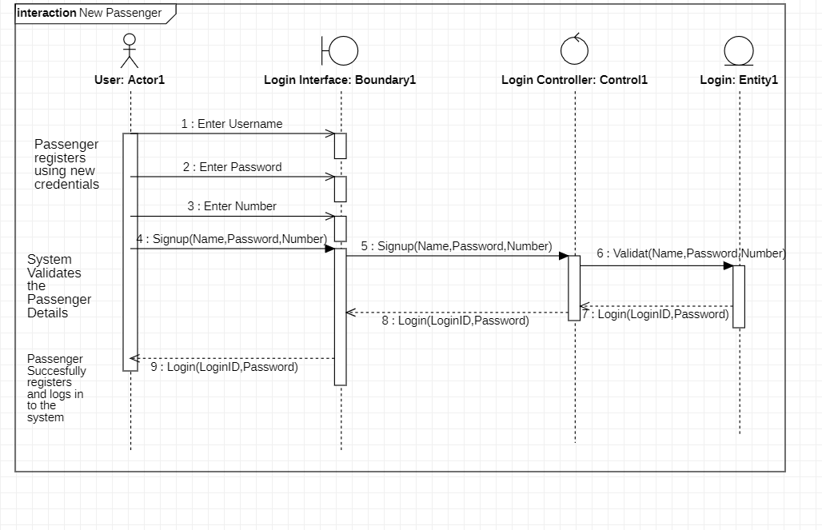

**ALTERNATE FLOW :**

* 1. Invalid Details

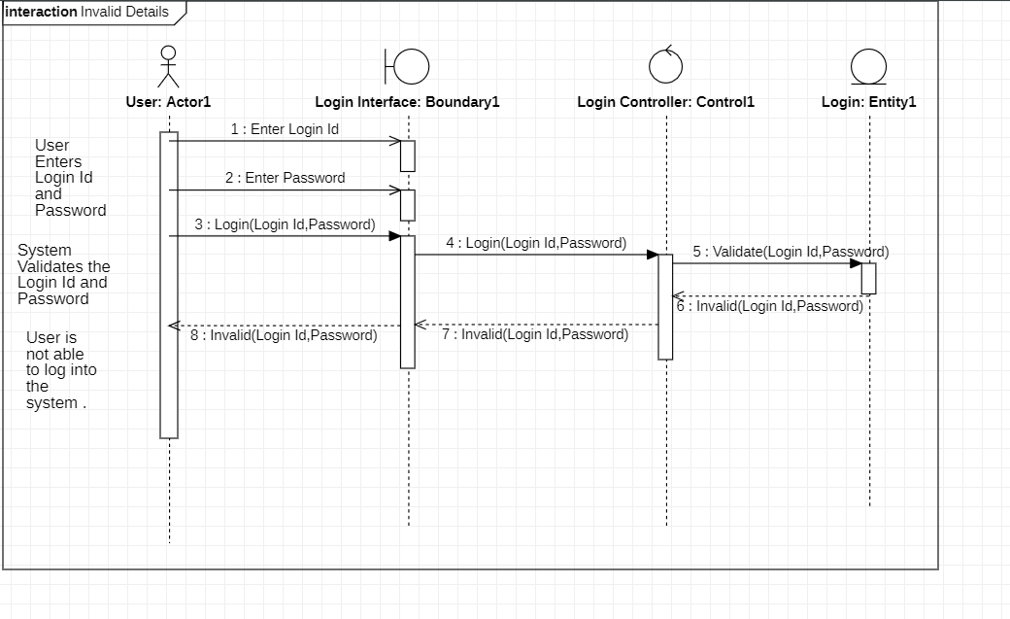

* 1. User Already Exist

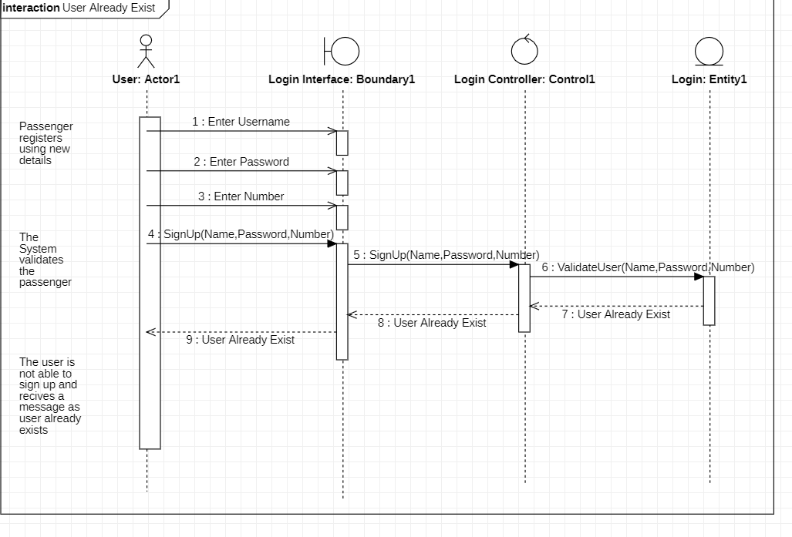

1. **BOOK TICKETS SEQUENCE DIAGRAM**

**BASIC FLOW**

2.1 Enter

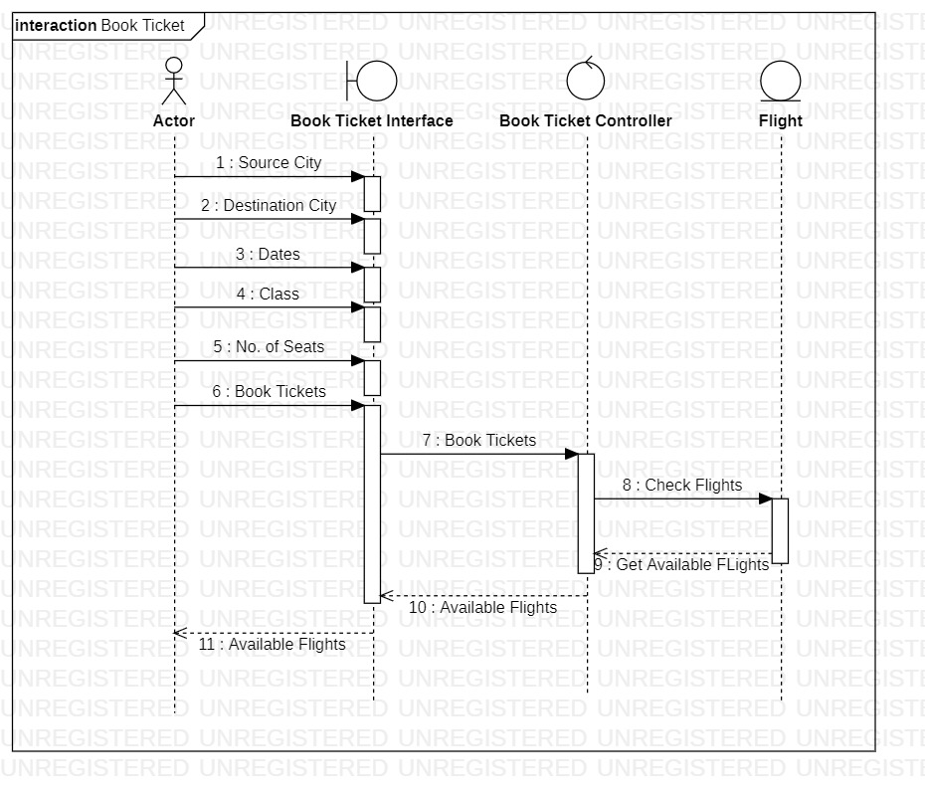

**ALTERNATE FLOW**

2.2 Invalid Details

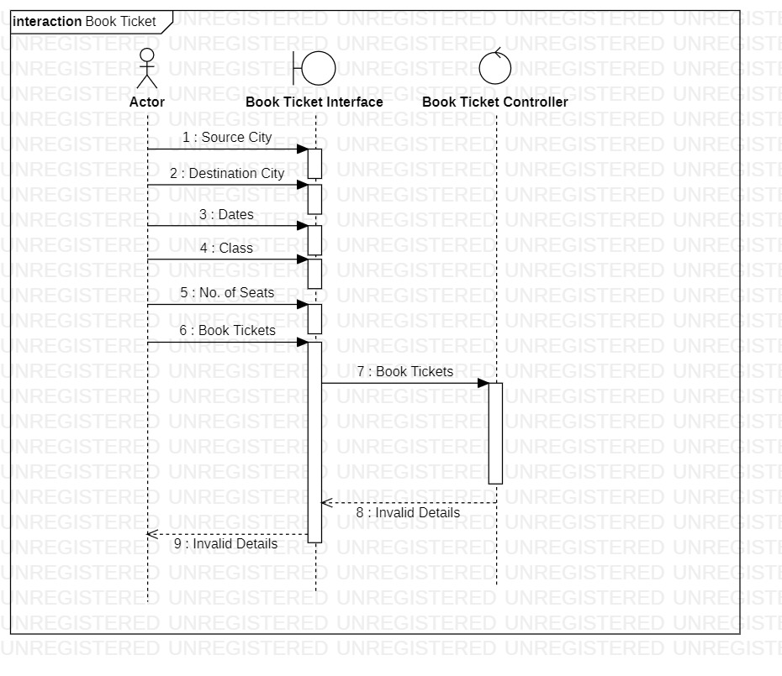

2.3 No flights available for selected Details

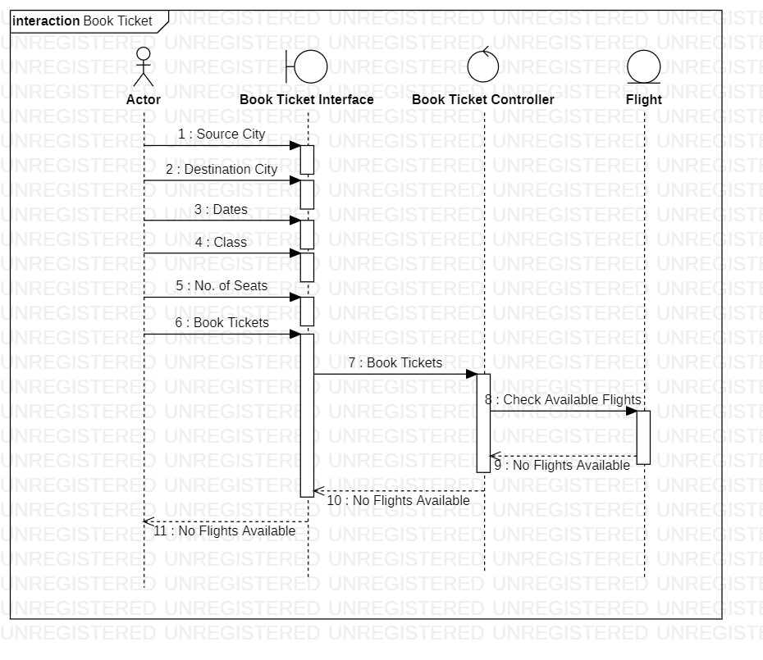

1. **VIEW TICKETS SEQUENCE DIAGRAM**

**BASIC FLOW**

3.1 Enter Details and view flights

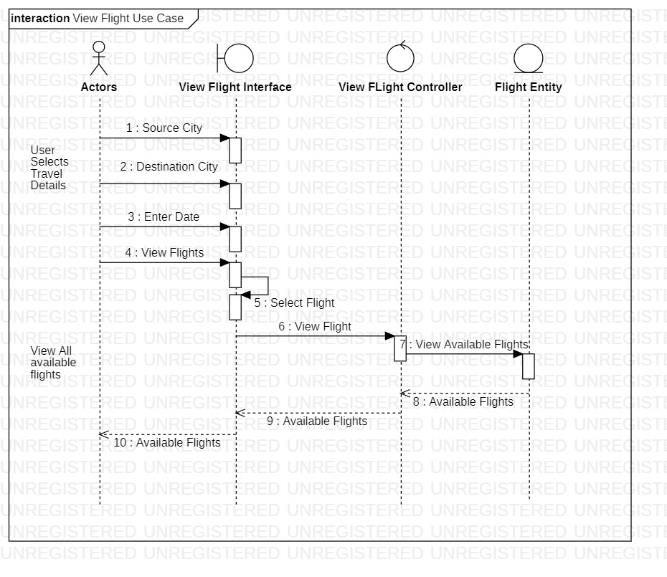

**ALTERNATE FLOW**

3.2 Source / Destination City is empty

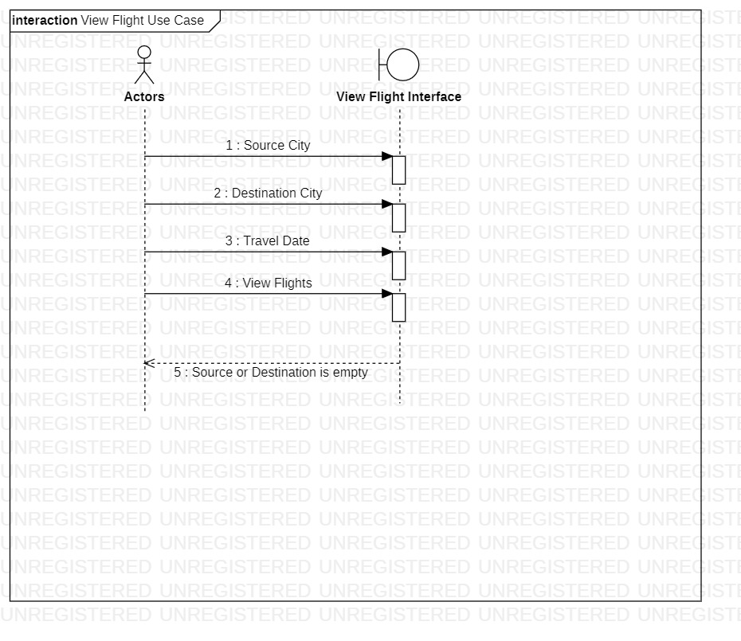

3.3 Travel Date is empty

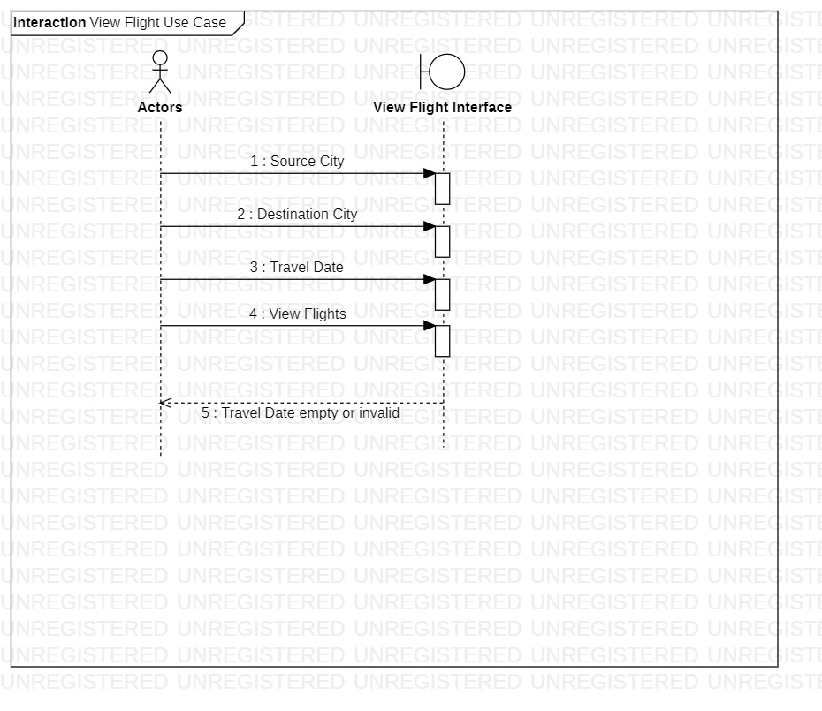

1. **MAKE PAYMENT SEQUENCE DIAGRAM**

**BASIC FLOW**

4.1 Add Payment details and make payment

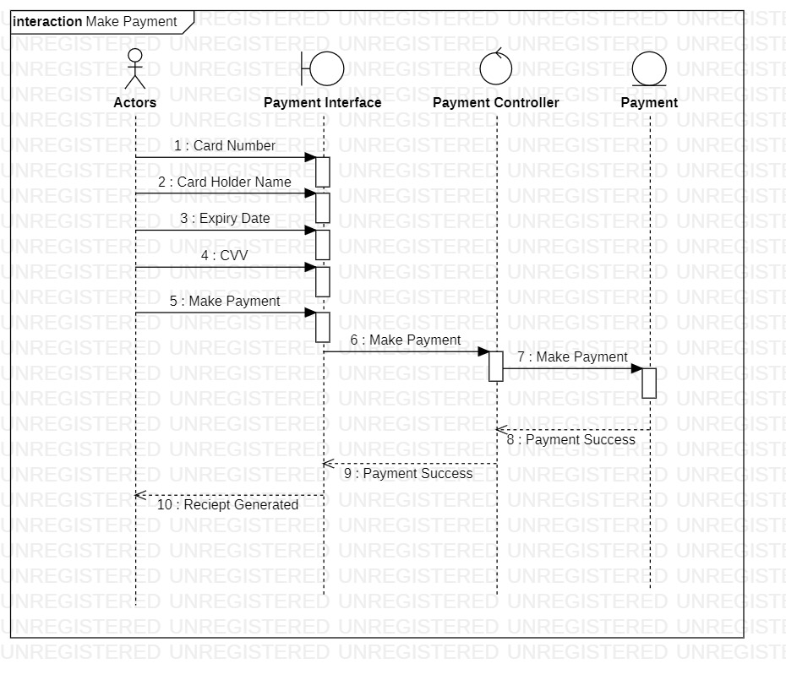

**ALTERNATE FLOW**

4.2 Invalid Payment Details

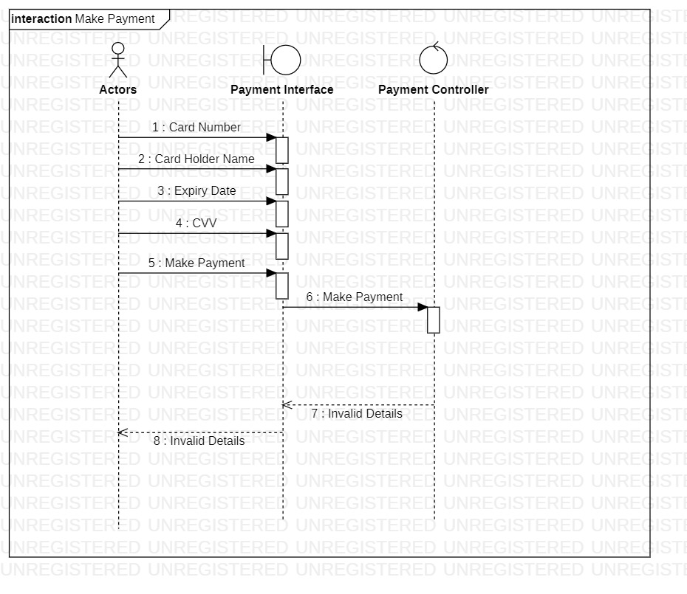

4.3 Time Exceeded – Transaction cancelled

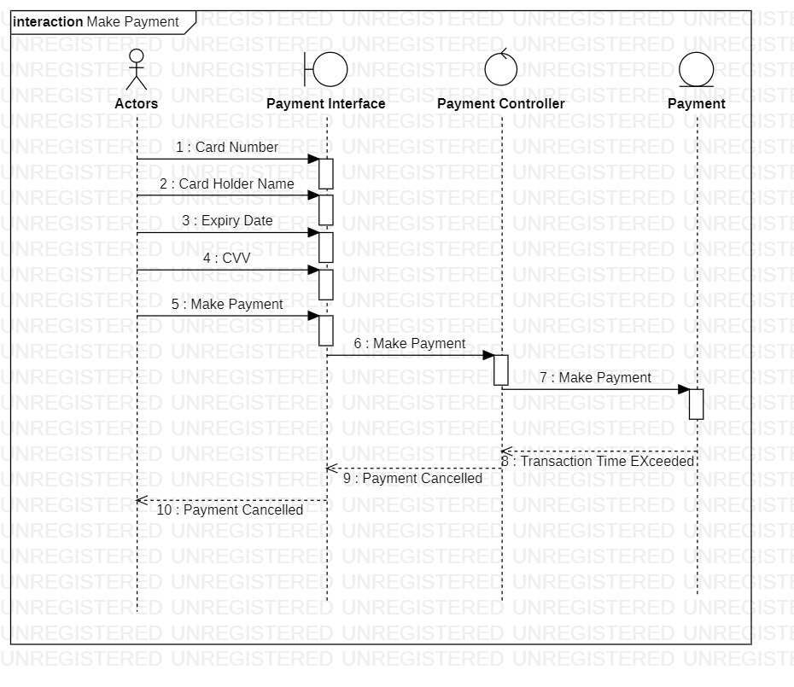

1. **CANCEL TICKETS SEQUENCE DIAGRAM**

**BASIC FLOW**

5.1 Cancel booked tickets

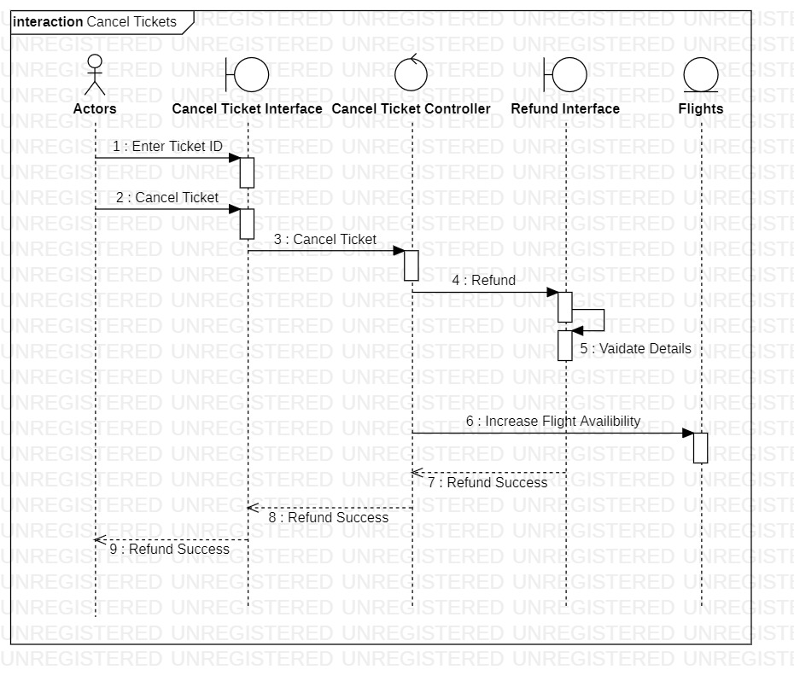

**ALTERNATE FLOW**

5.2 Invalid Details

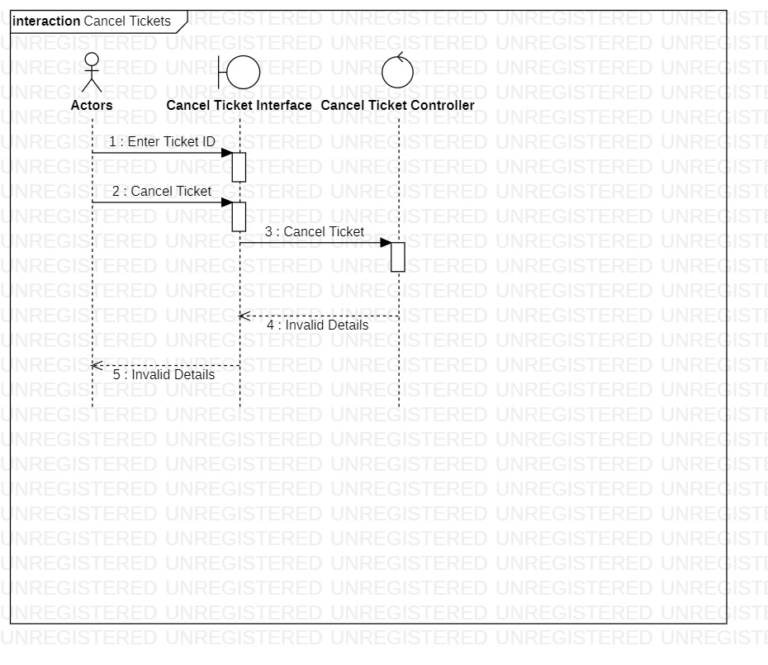

1. **REFUND SEQUENCE DIAGRAM**

**BASIC FLOW**

6.1 Refund paid amount for flight

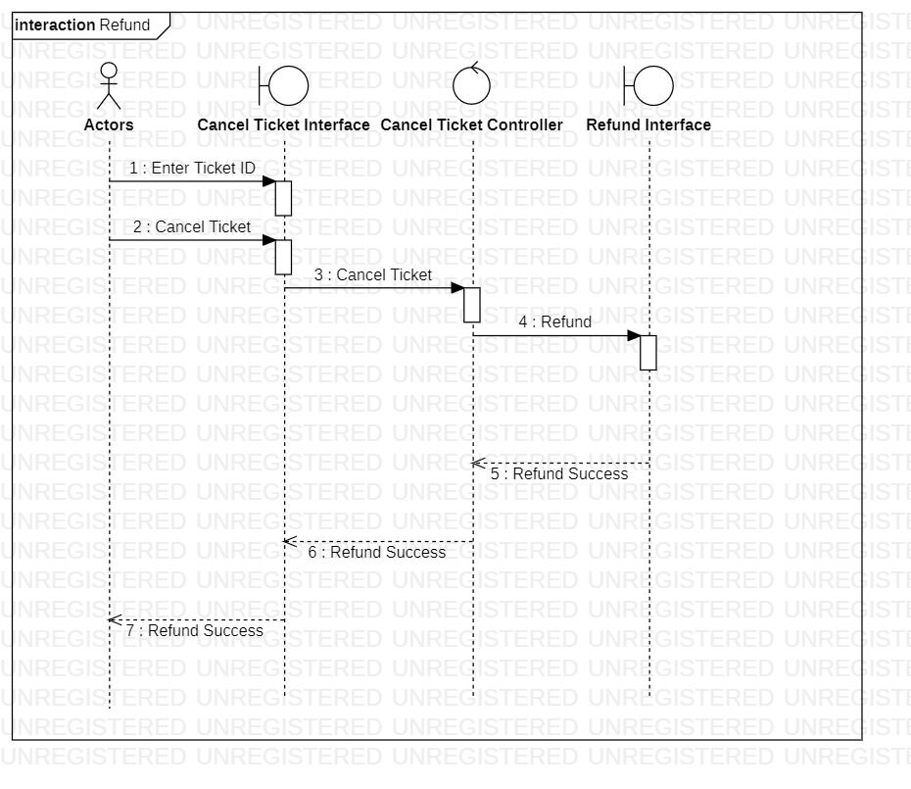

**ALTERNATE FLOW**

6.2 Invalid details of payment

